Das Burger Joint

POS System

User Guide

Papiya Rahman

Josh Alphonse

Daniel Leonard

Ryan Lott

Table of Contents

Logging in…………………………………………………………...3

Manage Users……………………………………………………….4

Ordering……………………………………………………………..5

Adding quantities …………………………………………………...6

Deleting orders……………………………………………………....7

Pricing……………………………………………………………….8

Kitchen View………………………………………………………..9

Logging in

To log in, enter your employee number and password into the indicated fields and press the “SUBMIT” button.

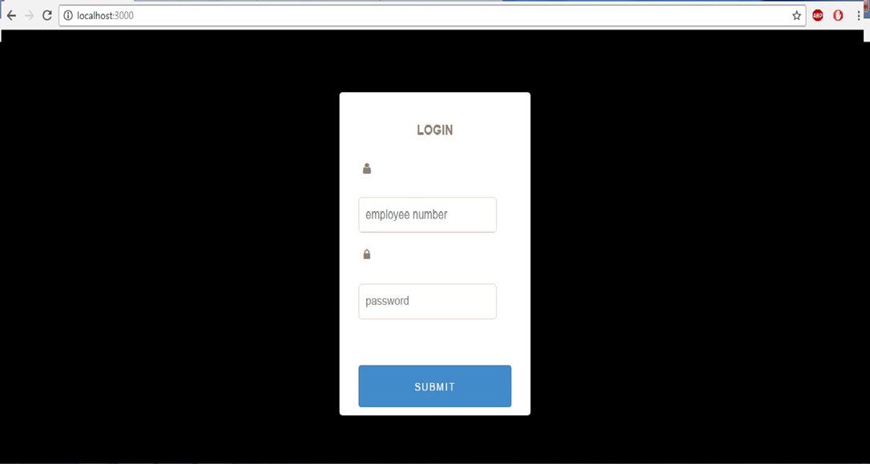

Manage Users

If you are a manager or admin, to see all existing users and edit them click on “Manage Users” at the top right side of the screen. This allows you to see all the current users on the left side of the screen under “User List”. If you click on a current user you can edit their information. You can also add users by inputting the required information and clicking the “Add/Update button”.

Current Users Manage Users Add/Update

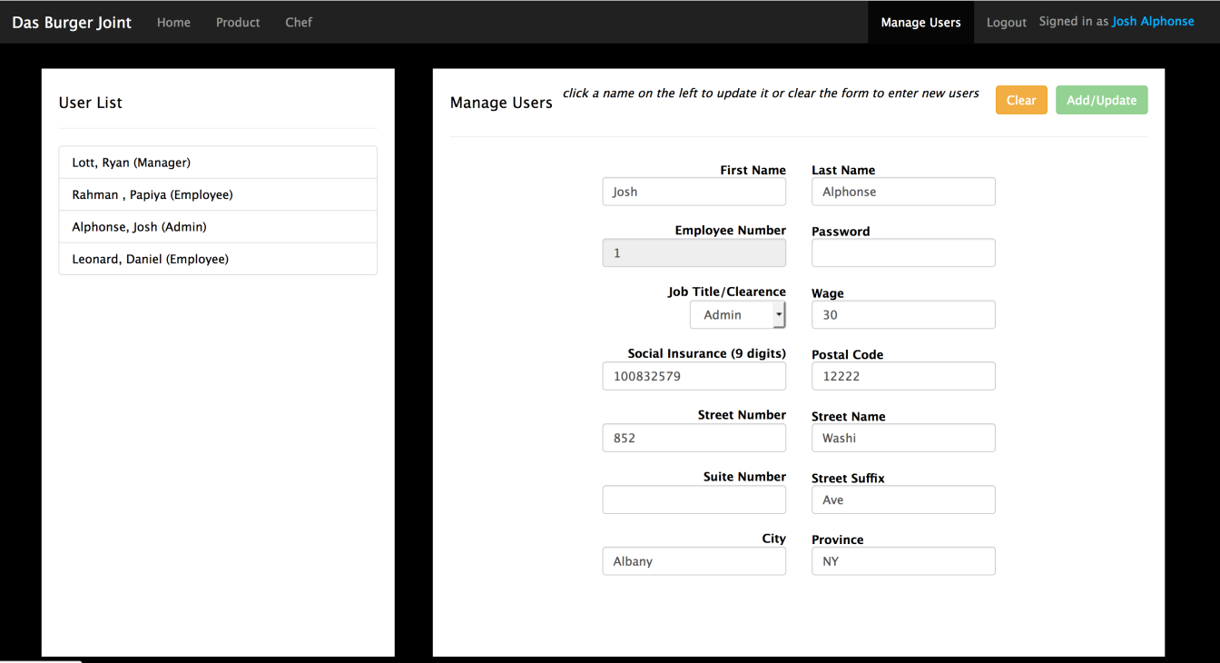

Ordering

To order click on the item from the menu you want. Click on the “BEVERAGE” and “FOOD” tabs to see the menu categorized. Once you click on an item, it will display on the left side of the screen. There is a special instructions section next to each food item where notes can be written for the chef such as “extra cheese”. Click the green “Purchase” Button to complete the order.

Special Instructions Beverage Food Tabs

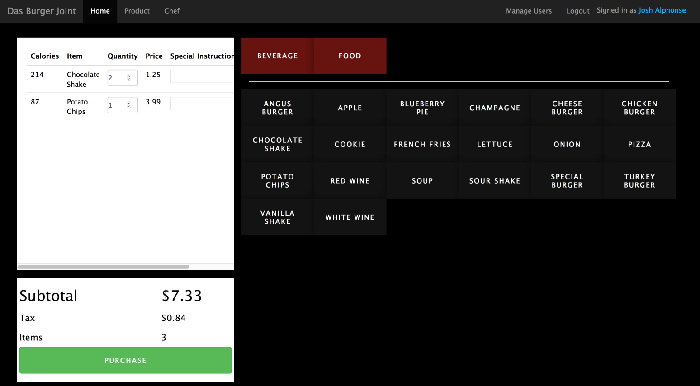

“Purchase” button

Adding Quantities

To add another one of the same item click the up arrow under the “Quantity” column. This will automatically update the price of the total order.

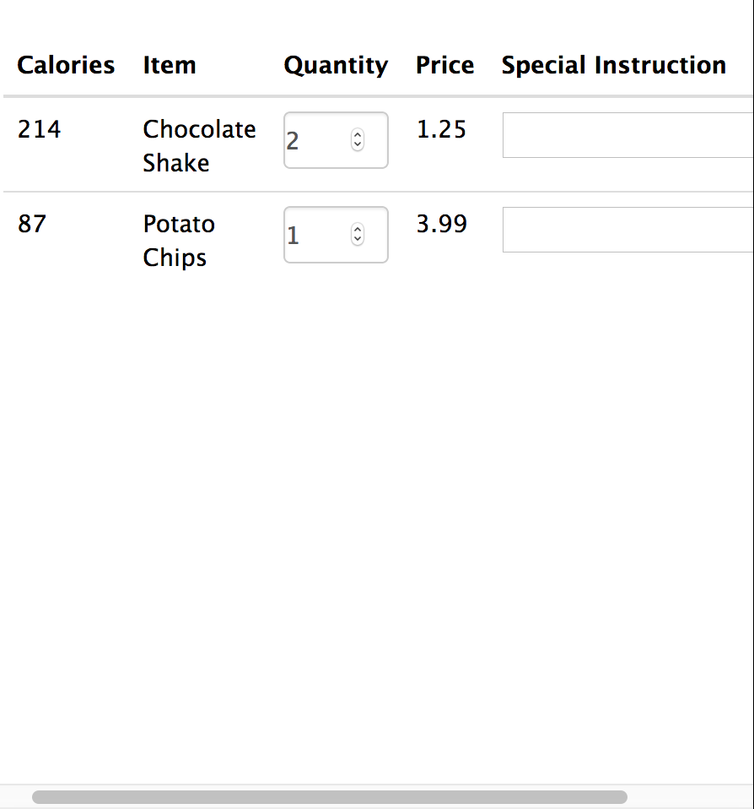 Up Arrow

Deleting Orders

To delete an order click on the down arrow under the “Quantity” column. This will automatically update the price of the total order. To complete delete the item from the order, keep clicking the down arrow; the quantity should decrease with each click and eventually the item will be removed from the order.

 Down Arrow

Pricing

The price of order will be calculated automatically. If you add an item the price will increase, if you delete an item the price will decrease. Tax is added to the order automatically. The order subtotal, tax and the amount of items ordered will e displayed at the bottom left of the screen.

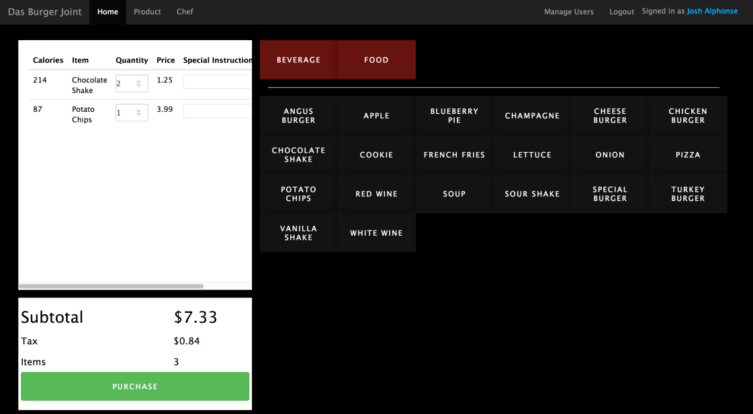

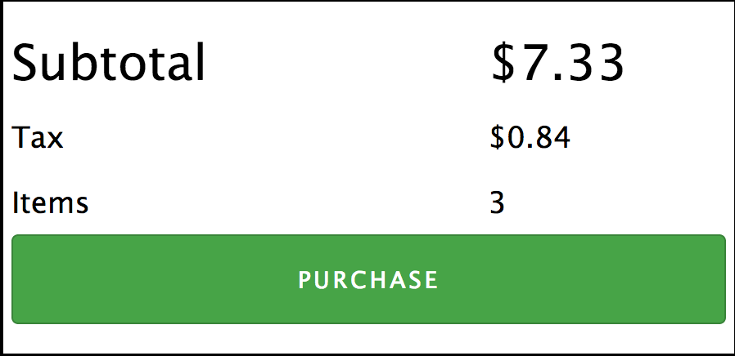

Kitchen View

Chefs, and anyone who wants to see what the chef will see, click on the “Chef” icon at the top left of the screen. This displays order and any special instructions the chef needs to complete the order.

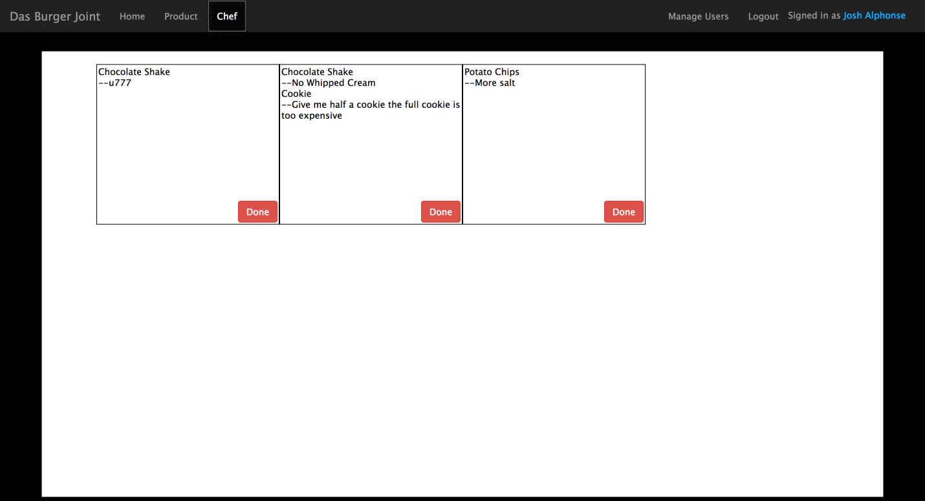

Chef icon one order

Special instructions